FL-01: AI Workflow Audit
Muhammad Hamza Nawaz — General AI Fluency track, FlyRank Internship

1. Task Classification Table
Recurring Task | Classification | Rationale
Studying for CS theory exams (automata, CFGs, computer architecture, DB systems) | Just me | Concepts need to live in my head for closed-book exams; AI-generated explanations don't survive exam pressure.
Designing ERDs / relational schemas for coursework (DB Lab, assignment projects) | Collaborate with AI | I own the design decisions, but AI is useful for sanity-checking normalization and generating sample data fast.
Writing FastAPI/backend code for internship + personal projects (HireFlow, NeoRetail, DentAI) | Collaborate with AI | Architecture and logic are mine; AI speeds up boilerplate, error handling, and first-draft endpoints I then review.
Git commits, branching, and history management | Just me | A past AI-assisted reset caused real data loss across three projects — this is a trust boundary I won't reopen.
Vetting new job postings/recruiters for legitimacy before applying | Collaborate with AI | AI can flag red flags fast (mismatched domains, vague models) but the final call on scams needs my own judgment.
Drafting cover letters / "why this company" notes | Delegate to AI with review | AI gets a strong first draft from the job post fast; I edit for accuracy and voice before sending.
Tailoring CV/resume variants per role (DevOps, LLM, QA, full-stack angles) | Delegate to AI with review | Repetitive reformatting task; I review every version so nothing is overstated (e.g. no inflated Django/n8n claims).
ATS optimization / keyword-matching a CV against a job description | Delegate to AI with review | Mechanical comparison task AI does well; I confirm nothing dishonest slips in to please the scanner.
Debugging dev-environment issues (touchpad, display scaling, power profiles) | Just me | These are machine-specific and trial-and-error; I learn more fixing them directly than delegating.
Writing/maintaining context_gen.py (genmd) and .ai_ignore/.ai_read rules | Just me | This tool decides what AI sees about my own projects, so I keep control of its logic.
Drafting Fiverr gig descriptions | Delegate to AI with review | Marketing copy is not my strength; AI drafts it, I check it still reflects what I can actually deliver.
Prioritizing which internship assignments / job applications to tackle this week | Collaborate with AI | I bring the constraints (deadlines, energy, priorities); AI helps me sequence and not miss anything.
Writing the AI Forensics DB Lab report and slides | Delegate to AI with review | First-draft structure and phrasing from AI saves time; I verify every technical claim before submission.
Tracking which companies I've applied to and their status | Fully automate | A simple log/spreadsheet update is pure bookkeeping — no judgment needed once the format is set.

2. Claude Project — Custom Instructions
Created a Claude Project ("Career & Dev Work") with the following custom instructions:
Who I am: BSCS student at SZABIST Islamabad, interning on the Backend AI Engineering track at FlyRank. I build Python backend + AI automation projects (FastAPI, RAG, agentic workflows) — not ML/data science.
Tone: Direct and honest over comfortable. Don't default to validating my current path or plans for the sake of being encouraging — give me the objectively better option based on market demand, skill level, and timeline when I ask you to compare things.
Current goals: Land a remote-first or Islamabad-based junior/internship role in Python backend + AI automation. Keep my job applications honest — never overstate WordPress, n8n/Make/Zapier, mobile, or Django experience; flag real gaps instead of hiding them.
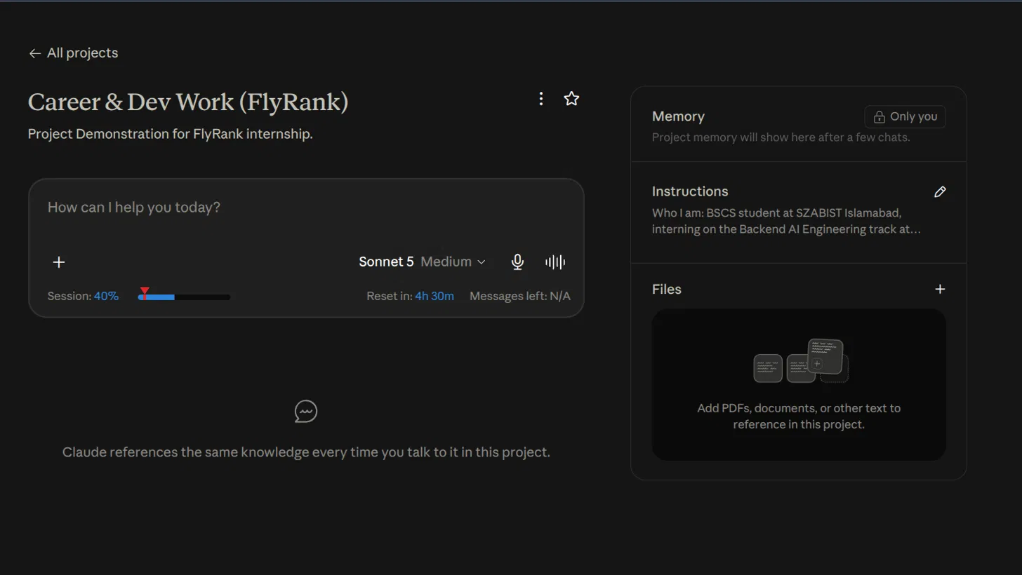
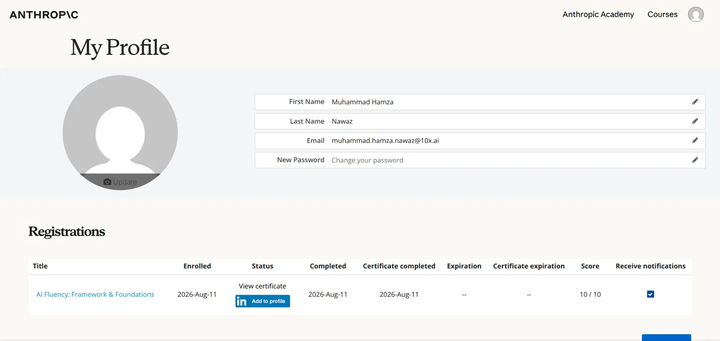

3. Three Target Tasks (for FL-02 → FL-04)
1. Company / recruiter legitimacy vetting
"Done well" = given a job post or recruiter message, I get a structured risk read (domain age, contact channel, model plausibility, red-flag checklist) in under 2 minutes, and I still make the accept/reject call myself.
2. Cover letter / "why this company" note drafting
"Done well" = first draft references specific, real details from the posting (not generic filler), matches my actual experience without inflation, and needs only light editing — not a rewrite — before I send it.
3. CV tailoring against a specific job description
"Done well" = the tailored CV highlights genuinely matching skills/keywords for that role, flags any real gaps instead of papering over them, and passes my own honesty check (nothing claimed that I can't back up in an interview).

